ELK
Elasticsearch,Logstash, Kibana

Introduction :
The first three components form what is called an ELK stack, whose main purpose is to collect logs from multiple servers at the same time (also known as centralized logging). A built-in java-based web interface allows you to inspect logs quickly at a glance for easier comparison and troubleshooting. These client logs are sent to a central server by Filebeat, which can be described as a log shipping agent.

Our Goal :
The goal of the tutorial is to set up Logstash to gather syslogs of multiple servers, and set up Kibana to visualize the gathered logs.
Our ELK stack setup has four main components:
- Logstash: The server component of Logstash that processes incoming logs
- Elasticsearch: Stores all of the logs
- Kibana: Web interface for searching and visualizing logs, which will be proxied through Nginx
- Filebeat: Installed on client servers that will send their logs to Logstash, Filebeat serves as a log shipping agent that utilizes the lumberjack networking protocol to communicate with Logstash

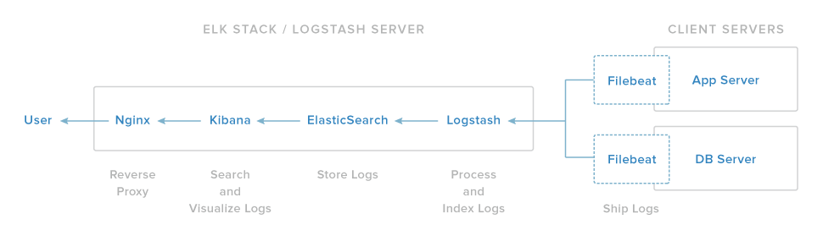
We will install the first three components on a single server, which we will refer to as our ELK Server. Filebeat will be installed on all of the client servers that we want to gather logs for, which we will refer to collectively as our Client Servers.

Prerequisites :
To complete this tutorial, you will require root access to an CentOS 7 VPS.
If you would prefer to use Ubuntu instead, check out this tutorial.
The amount of CPU, RAM, and storage that your ELK Server will require depends on the volume of logs that you intend to gather. For this tutorial, we will be using a VPS with the following specs for our ELK Server:
- OS: CentOS 7
- RAM: 4GB
- CPU: 2
Installation

---------------------------
---------------------------

1 - install Java JDK version 8 (update 102, the latest one at the time of this writing), which is a dependency of the ELK components.
[root@pc ~]# cd /opt

[root@pc ~]#wget https://mirror.its.sfu.ca/mirror/CentOS-Third-Party/NSG/common/x86_64/jdk-8u102-linux-x64.rpm

[root@pc ~]# yum localinstall jdk-8u102-linux-x64.rpm

[root@pc ~]# vim .bash_profile
Add lines :
export JAVA_HOME=/usr/java/jdk1.8.0_102/

export JRE_HOME=/usr/java/jdk1.8.0_102/jre

PATH=$PATH:$HOME/bin:$JAVA_HOME/bin

export PATH

Check With :
[root@pc ~]# java -version

2- Installation for Elasticsearch :

Enable Elasticsearch Repository

- Import the Elasticsearch public GPG key to the rpm package manager:

[root@pc ~]# rpm --import http://packages.elastic.co/GPG-KEY-elasticsearch

- Insert the following lines to the repository configuration file elasticsearch.repo:

[root@pc ~]# vim /etc/yum.repos.d/elasticsearch.repo
[elasticsearch]
name=Elasticsearch repository
baseurl=http://packages.elastic.co/elasticsearch/2.x/centos
gpgcheck=1
gpgkey=http://packages.elastic.co/GPG-KEY-elasticsearch
enabled=1
[root@pc ~]# yum install elasticsearch

When the installation is complete, you will be prompted to start and enable elasticsearch:

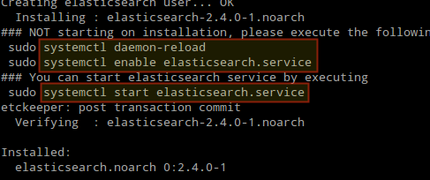

3. Environment need to be set.

[root@pc ~]# Vim /etc/elasticsearch/elasticsearch.yml

network.host: localhost

[root@pc ~]# vim /usr/lib/systemd/system/elasticsearch.service

Environment=JAVA_HOME=/usr/java/jdk1.8.0_102

[root@pc ~]# vim /usr/share/elasticsearch/bin/elasticsearch

ES_JAVA_OPTS="-Des.insecure.allow.root=true"

[root@pc ~]# vim /usr/lib/systemd/system/elasticsearch.service

-Des.default.path.conf=${CONF_DIR} \

-Des.insecure.allow.root=true

4. Start and enable the service.

# systemctl daemon-reload
# systemctl enable elasticsearch
# systemctl start elasticsearch
5. Allow traffic through TCP port 9200 in your firewall:
# firewall-cmd --add-port=9200/tcp
# firewall-cmd --add-port=9200/tcp --permanent
- Check if Elasticsearch responds to simple requests over HTTP:
#curl -X GET http://localhost:9200

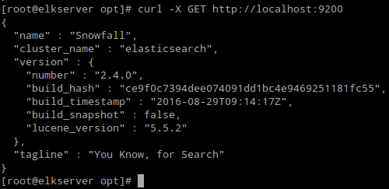

Install Logstash :
Enable Logstash Repository

1. Insert the following lines to the repository configuration file logstash.repo:
[root@pc ~]# vim /etc/yum.repos.d/logstash.repo
[logstash]
name=Logstash
baseurl=http://packages.elasticsearch.org/logstash/2.2/centos
gpgcheck=1
gpgkey=http://packages.elasticsearch.org/GPG-KEY-elasticsearch
enabled=1
2. Install the Logstash package:
# yum install logstash
3. Add a SSL certificate based on the IP address of the ELK server at the the following line below the [ v3_ca ] section in /etc/pki/tls/openssl.cnf:

[ v3_ca ]
subjectAltName = IP: 192.168.124.122

- Generate a self-signed certificate valid for 365 days:

# cd /etc/pki/tls
# openssl req -config /etc/pki/tls/openssl.cnf -x509 -days 3650 -batch -nodes -newkey rsa:2048 -keyout private/logstash-forwarder.key -out certs/logstash-forwarder.crt
- Configure Logstash input, output, and filter files:

Input: Create /etc/logstash/conf.d/input.conf and insert the following lines into it. This is necessary for Logstash to “learn” how to process beats coming from clients. Make sure the path to the certificate and key match the right paths as outlined in the previous step:

# vim /etc/logstash/conf.d/input.conf
input {
beats {
port => 5044
ssl => true
ssl_certificate => "/etc/pki/tls/certs/logstash-forwarder.crt"
ssl_key => "/etc/pki/tls/private/logstash-forwarder.key"
}
}
Output (/etc/logstash/conf.d/output.conf) file:
# vim /etc/logstash/conf.d/output.conf
output {
elasticsearch {
hosts => ["localhost:9200"]
sniffing => true
manage_template => false
index => "%{[@metadata][beat]}-%{+YYYY.MM.dd}"
document_type => "%{[@metadata][type]}"
}
}

Filter (/etc/logstash/conf.d/filter.conf) file. We will log syslog messages for simplicity:
/etc/logstash/conf.d/filter.conf
filter {
if [type] == "syslog" {
grok {
match => { "message" => "%{SYSLOGLINE}" }
}
date {
match => [ "timestamp", "MMM d HH:mm:ss", "MMM dd HH:mm:ss" ]
}
}
}

Verify the Logstash configuration files.

[root@pc ~]# /etc/init.d/logstash configtest

Configuration OK

6. Start and enable logstash:
# systemctl daemon-reload
# systemctl start logstash
# systemctl enable logstash

7. Configure the firewall to allow Logstash to get the logs from the clients (TCP port 5044):
# firewall-cmd --add-port=5044/tcp
# firewall-cmd --add-port=5044/tcp --permanent

Install Kibana :

Enable Kibana Repository
1. nsert the following lines to the repository configuration file kibana.repo:
[root@pc ~]# /etc/yum.repos.d/kibana.repo
[kibana]
name=Kibana repository
baseurl=http://packages.elastic.co/kibana/4.4/centos
gpgcheck=1
gpgkey=http://packages.elastic.co/GPG-KEY-elasticsearch
enabled=1
2. Install the Kibana package:
[root@pc ~]# yum install kibana

3. Start and enable Kibana.
# systemctl daemon-reload
# systemctl start kibana
# systemctl enable kibana
4. Launch Kibana http://192.168.124.122:5601 to verify that you can access the web interface:

We will return here after we have installed and configured Filebeat on the clients.

Install Filebeat on the Client Servers

Configure Filebeat
Vim /etc/filebeat/filebeat.yml

1. Under paths, indicate which log files should be “shipped” to the ELK server.
2. Under prospectors:

input_type: log
document_type: syslog
Under output:
  - Uncomment the line that begins with logstash.
  - Indicate the IP address of your ELK server and port where Logstash is listening in hosts.
  - Make sure the path to the certificate points to the actual file you created in Step I (Logstash section) above.
The above steps are illustrated in the following image:

[root@PCX ~]# /etc/init.d/filebeat restart

Testing Filebeat on Server:

[root@pc ~]# curl -XGET 'http://localhost:9200/filebeat-*/_search?pretty'

Enter filebeat-* in the Index name or pattern field and then click Create:

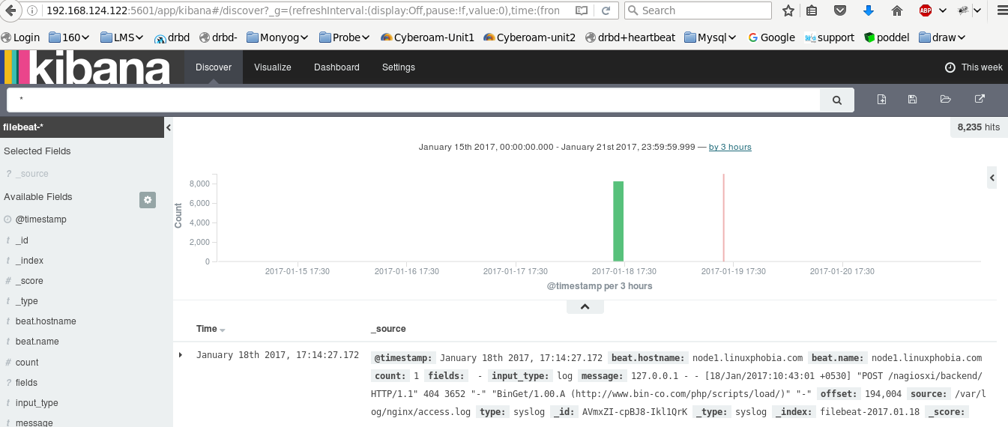

Create graph:

1- Create a new visualization
2- click on Pie chart
3- select from new search

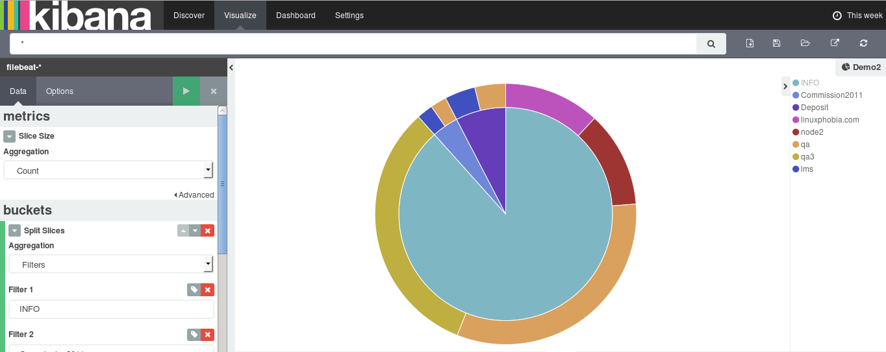

Now create a Dashboard:

